BREAKFAST CHATTER
Weekly Bulletin of Rotary Club of Kathmandu Mid-Town
District 3290 Volume No. 15/19 for #761 November 28, 2004
www.rotarymidtown.org.np
NOVEMBER IS ROTARY FOUNDATION MONTH

SUNSHINE ANNOUNCEMENT FOR THE WEEK OF 26 NOVEMBER 2004;
Birthday greetings to William on the 29th, and congratulations to Mani + Sunita on December 3rd.
*********** MEETING ACTIVITIES:
DATE | ACTIVITY | SUBJECT
28 NOV | Tilganga Medical Camp | M-T Members support the professionals
28 NOV | Dinner Meeting--Annapurna | Combo: Charter Night & Taiwan Guests
3 DEC | Shyam Nepali | the best of Sarangi
10 DEC | Rabi Karmacharya | Software Outsourcing Prospects for Nepal
DEC or JAN | Health Camps | Naubise & Tistung with ADRA/Hartmut
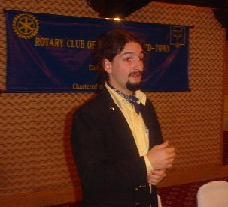
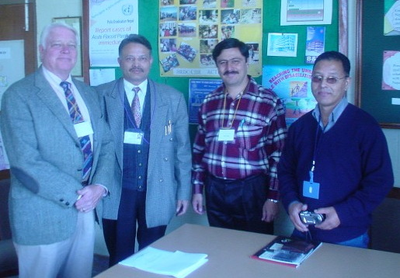
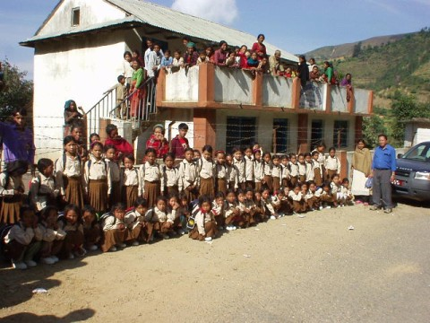
**************** NEWS: NO MEETING ON FRIDAY!!!!!! *** Jean Christoph Ryckman’s presentation on Chandrodaya program for the street children was well received. M-T members offered to make introductions to the Dillibazaar club, near Chandrodaya’s new facility. Funds to help launch the new site will be appreciated. *** M-T’s Rotaractors are forming an Interact Club for in Kirtipur with Lekha as Advisor *** M-T Rotarians visit Banepa for continuing discussions with HRDC Executive Director Krishna Bhattarai *** A health camp, with ADRA help is proposed for Naubise and Tistung, near the school that Rtn Hartmut knows. School and children are shown here.
**************** THIS WEEK’S EVENT IS THE MEDICAL CAMP (PROGRAM 51851)
Beneficiaries are an estimated 1,500 adults (not kids this time) living near Pashupati. Men & women will be screened separately for medical needs. Over 60’s also get cataract test. Eye patients will get operation later at K’du Medical College under Rotary’s ‘Avoidable Blindness’ program. There will be a small pharmacy. M-T and 15 Rotarians from 7 Taiwan clubs will help with the Medical Camp Registration (7:30AM..) and ‘Winding Up’ (4>>5PM). Many Rotaract & professional volunteers are coming. B’fast, veg-lunch and tea are included for all volunteers. Enlisted are: DvidS, WernerB, AnandT, SarojS, ManiJ, JyotsnaS, PeterC, WilliamM, RRS, VispyM, NavyoE, ArunS, & BiswajitC. To join, please email DavidS. The Taiwanese guests will also get a tour of the Shanti Sewa Griha facility.
**************** Please join us! YIR…David

